PHÒNG GD & ĐT QUẬN LONG BIÊN ĐỀ THI HỌC KỲ I
Trường THSC Bồ Đề Môn: Tiếng Anh 6
Date: / / 2016
Name:...........................................
Class: 6A…
Mark | Teacher’s remarks
I. Listen and choose the best answer (1pt)
1. Where does her brother work? 2. How does he go to school?
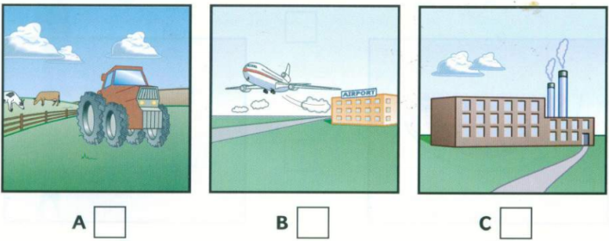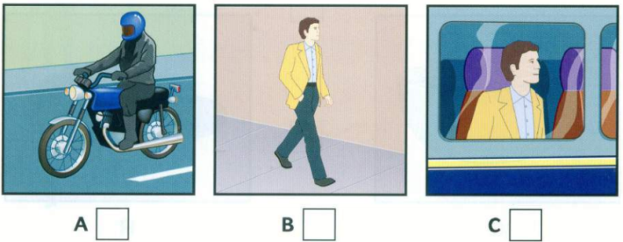
3. When does he start work? 4. What does he has for lunch?
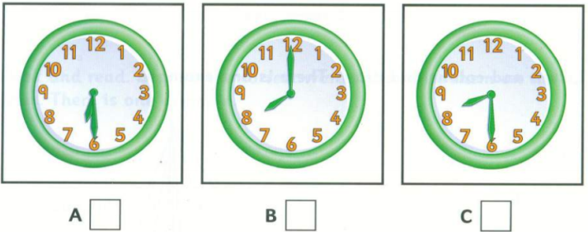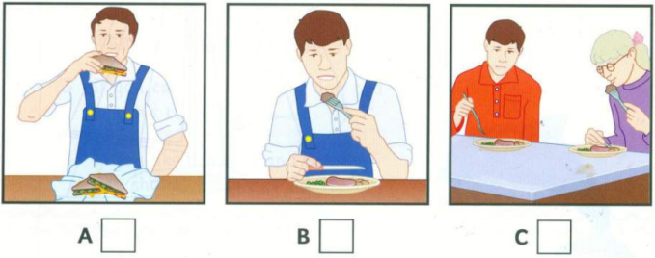
II. Read the passage and tick True (T) or False (F) (1pt)
Mount Fansipan – the Roof of Indochina
Fansipan is a mountain in Viet Nam. At 3,143 metres, it is the highest mountain in Indochina. It is located in the Lao Cai Province in Northwest Viet Nam, 9 km southwest of Sa Pa Township in the Hoang Lien Son Mountain Range. Due to its high elevation, Fansipan is called "the Roof of Indochina". With about 2,024 floral varieties and 327 faunal species, it is to be approved as one of the very few famous ecotourist spots of Viet Nam. You can climb through the trails to the peak of the mountain and observe the sunset. The best time to travel is between October and March when wild flowers are in bloom. Fansipan Mountain has long been the destination for those who are fond of exploring.
 | T | F
5.Mount Fansipan is in the Northwest Viet Nam.
6.It is one of the most famous ecotourist spots in Viet Nam.
7. It is the highest mountain in the world.
8. Between October and March is the best time to travel.

III. Put the verbs into the correct form (1pt)
9. My sister often (take)……………… a bus to work, but today she (ride) …………………….a bike.
10. The Moon (go)…………………………………………………………..……around the Earth.
11. Listen! The bird (sing)………………………………..……………….………………………….
12. We (not like) ……………………………………….…………….……playing chess very much.
IV. Choose the correct answers (2pts)
13. Ouch! I cut my finger. Can you give me the …………….?
A. plaster B. sun cream C. compass D. walking boots
14. Children….....................climb the trees.
A. shouldn’t B. should C. must D. mustn’t
15. What is Jane like? – ……………………….
A. Shee likes pizza. B. She doesn’t like pizza.
C. She has short hair. D. She is kind and helpful.
16. ……………... was you born?
A. How B. Why C. What D. When
17. There ………………..some sugar in the jar.
A. is B. are C. have D. has
18. Jane had a car accident…………..she is in hospital now.
A. but B. so C. because D. and
19. Which word has the different underline sound?
A. sun B. sure C. swim D. sing
20. Which word has the different underline sound?
A. cook B. clean C. celebrate D. candy
V. Fill in the blank with a suitable given word (1pt)
visit pagoda good clean do
Tet is a special occasion of every country in the world. People often (21)…………..….. the furniture, decorate the house and (22)…………..……. a lot of shopping before Tet. Everyone, especially children, is happy to welcome a new year. During Tet, people usually (23)…………. their relative, give lucky money, go to a (24)…………….. and wish others good things in life. Tet is a great time for all family gatherings. They can have traditional meal together and share what they have done in a year.
VI. Rewrite the sentences without changing the meaning (1pt)
25. Please tell me the way to the bank.
=> Can……………………………………………………………………..……………………?
26. She has long hair.
=> Her…………………………………………………………………………….………………
27. Travelling by airplane is more expensive than by train.
=> Travelling by train……………………………………………………………….………..
28. No one in the class is more hard-working than Tom.
=> Tom is………………………………………………………………………………..………..
VII. Re-arrange to make correct sentences. (1pt)
29. there/ Is/ a/ bank/ here?/ near
=> ………………………………………………………………………………………………...
30. Where/ you/are/going?
=> …………………………………………………………………………………………………
31. the/We/ follow/ must/ rules.
=> ……………………………………………………………………………………………..…..
32. Tet/ a time/ is/ family gatherings./ for
=> ……………………………………………………………………………………………..…..
------------------------THE END-----------------------

ĐÁP ÁN
I. Listen and choose the best answer (1pt)
Mỗi câu đúng 0.25 đ
1. C 2. A 3. B 4. A
* Tapescript:

1. What’s Sue’s brother job ?
- Where does your brother work?
- Oh, he wanted to work on a farm but he couldn’t find a job like this.
- Where is he working then?
- He’s found a job in a factory outside the town. It’s near the airport.
2. How does he go to work?
- How does he go to work everyday? Is there a bus?
- Well, there is a bus but it is slow.
- He doesn’t walk, does he? It’s too far.
- No. My Dad gave him a motorike. It’s fast.
3. When does he start work?
- That’s good. What time does he have to start work in the morning?
- He has to get up at half past six.
- That’s early. He doesn’t start work then, does he?
- No. Work starts at eight but he needs half an hour to get there.
4. What does he has for lunch?
- Does he come home for lunch?
- No, he has 30 minutes so he cannot come home.
- Is there a restaurant?
- Yes,but he doesn’t like the food so my mother makes he some sandwiches.
II. Read the passage and choose the best answer (1pt)
Mỗi câu đúng 0.25đ
5. T 6. T 7. F 8. T
III. Put the verbs into the correct form (1pt)
Mỗi câu đúng 0.25đ
9. takes/is riding 10. goes 11. is singing 12. don’t like
IV. Choose the correct answers (2pts)
Mỗi câu đúng 0.25đ
13. A 14. A/D 15. D 16. D 17. A 18. D
19. B 20. C
V. Fill in the blank with a suitable given word (1pt)
Mỗi câu đúng 0.25đ
21. clean 22. do 23. visit 24. pagoda
VI. Rewrite the sentences without changing the meaning (1pt)
Mỗi câu đúng 0.25đ
25. Can you tell me the way to the bank?
26. Her hair is long.
27. Travelling by train is cheaper than by airplane.
28. Tom is the most hard-working student in class.
VII. Re-arrange to make correct sentences. (1pt)
Mỗi câu đúng 0.25đ
29. Is there a bank near here?
30. Where are you going?
31. We must follow the rules.
32. Tet is a time for family gatherings.
-- -o0o- --
BGH duyệt Nhóm trưởng Người ra đề

Phòng GD & ĐT quận Long Biên
MA TRẬN ĐỀ THI HỌC KỲ I
MÔN: TIẾNG ANH LỚP
NĂM HỌC 2016 - 2017

Trường THSC Bồ Đề
-------o0o-------
I. Aims:
- Check the knowledge (from unit 1 to unit 6) which students have learned in the class.
- Help students realize the mistakes so that they can improv their marks next time.
II. Language Focus:
- Must/ Mustn’t/ Should/ Shouldn’t
- Comparison: Comparative and Superlative
- And/But/So
- Verb Be and Have for descriptions
- Prepositions of place
- Classroom expressions
- Present Simple/ Present Continuous

III. Objectives:

- Listen and choose the best answer.
- Which word is pronounced differently?
- Read the passage and choose the best answer
- Put the verbs into the correct form
- Choose the correct answers
- Fill in the blank with a suitable given word
- Rewrite the sentences without changing the meaning
- Re-arrange to make correct sentences

Content topic | Thinking level
Objectives to be tested | Recall/ Recognition | Comprehension/  Understanding | Application
Listening |  | 4 x 0.25p
Pronunciation | 2 x 0.25p
Reading | 4 x 0.25p | 4 x 0.25p
Writing | 4 x 0.25p |  | 4 x 0.25p
Vocabulary & Grammar | 4 x 0.25p | 4 x 0.25p | 2 x 0.25p
Speaking
Total number of questions | 14 | 12 | 6
Total of mark | 3.5 pts | 3.0 pts | 1.5 pts

